



ADSE-I

**Fitness Tracker**



* **GROUP MEMBERS NAMES**
  + - RABIA KANWAL ( 1421223 )
    - SHAIKH MINHAJ UDDIN ( 1398610 )
    - FILZA ( 1455894 )
    - TOOBA TARIQ ( 1419863 )

The

**Developer**

Guide

**System Requirements**

|  |
| --- |
| **Software** |
| * Windows OS /MongoDB/Express/React/Node.js/Notepad |
| **Hardware** |
| 1. A minimum computer system that will help you access all the tools in the courses is a Pentium 166 or better |
| 1. 128 Megabytes of RAM or better |
| 1. Windows 2000 Server (or higher if possible) |

* **OUR PROJECT code for developer guide**

**//MAIN SCREEN**

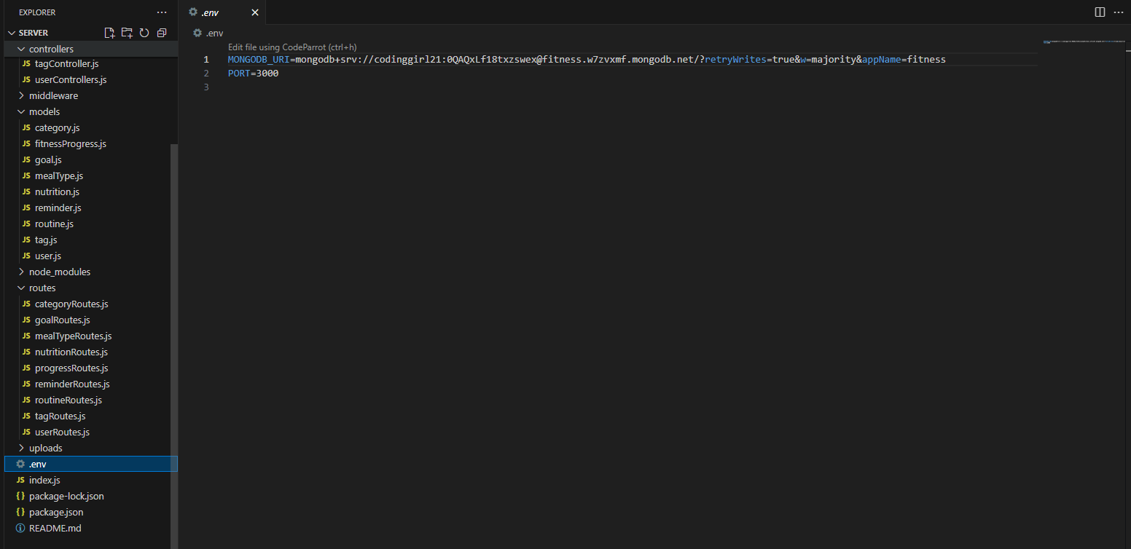

**//REGISTER PAGE**

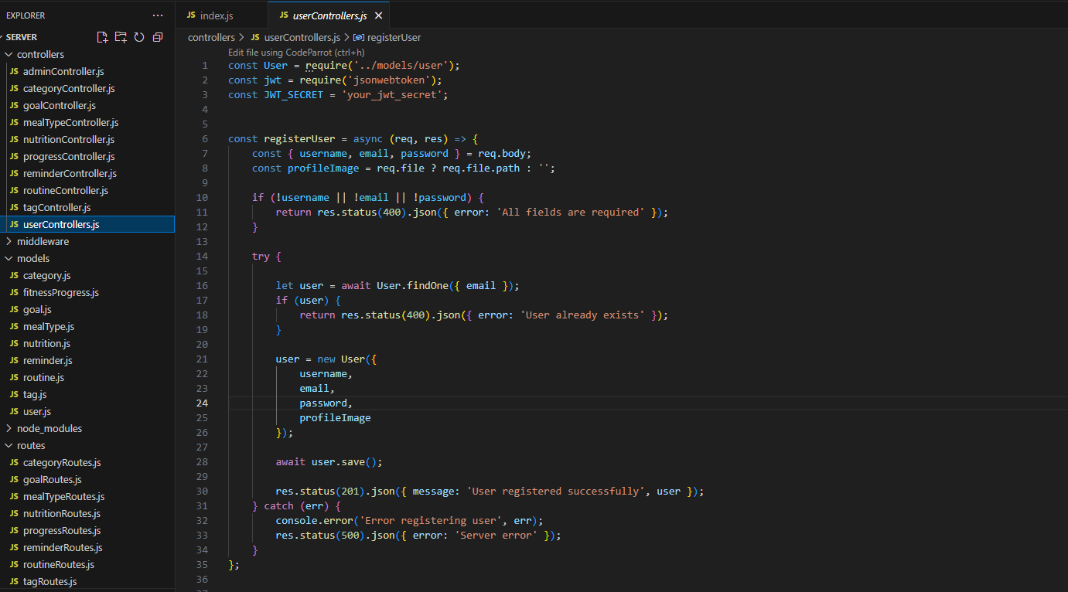

**//LOGIN PAGE**

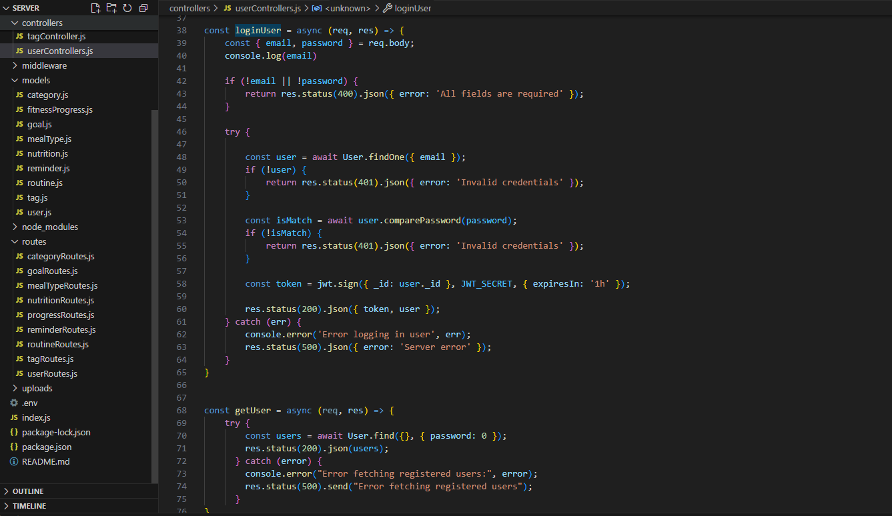

**//INDEX PAGE**

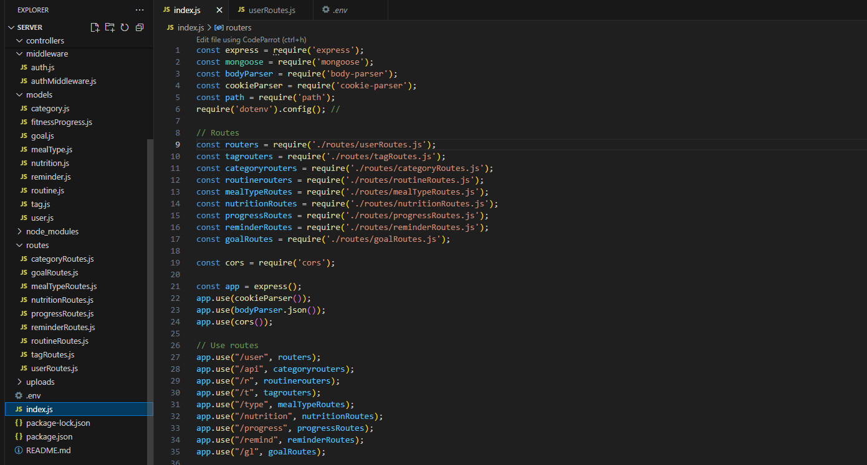

**//AUTHENTICATION(MIDDLEWARE)**

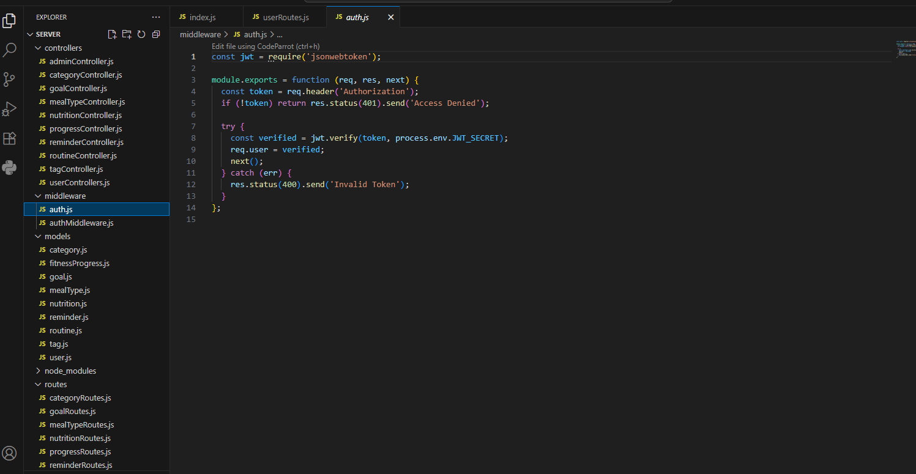

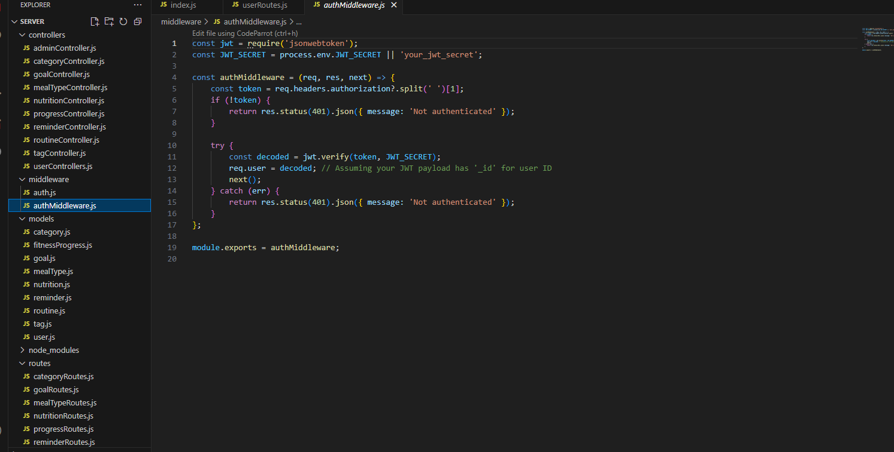

**//USER (CONTROLLER)**



**//USER SCHEMA(MODELS)**

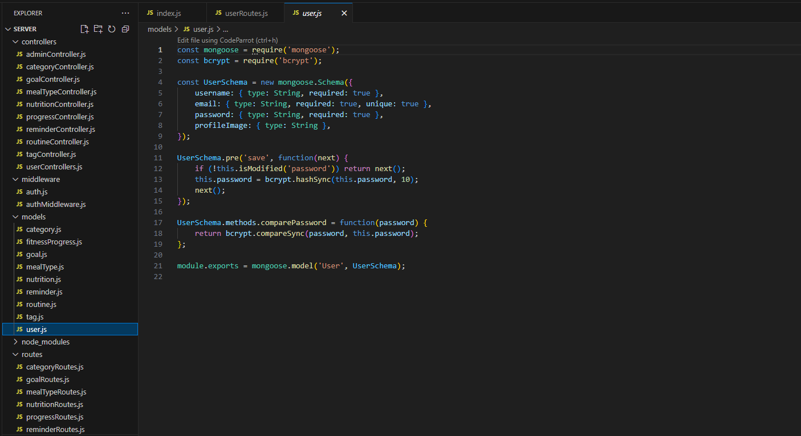

**//USER(ROUTES)**

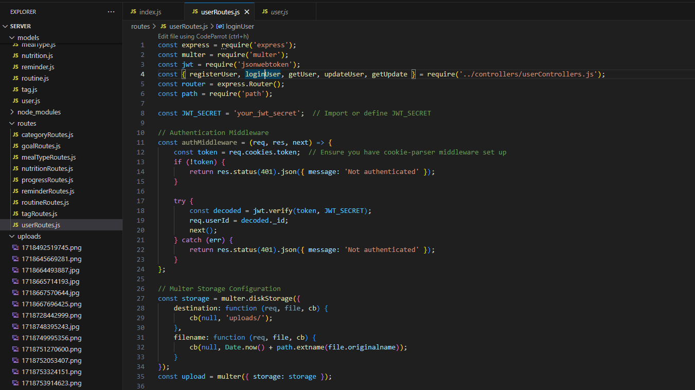

**//ATLAS(DATABASE)**

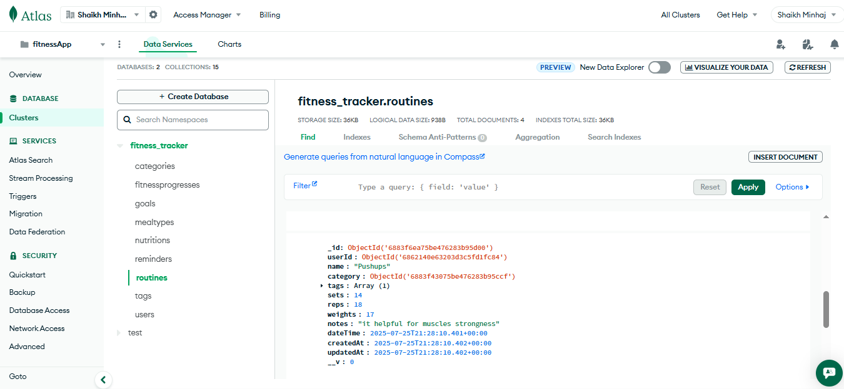

**DEVELOPER GUIDE SUMMARY**

* The **Fitness Tracker Developer Guide** is a comprehensive resource designed for developers tasked with building, maintaining, and enhancing the Fitness Tracker platform. It provides essential technical information, coding standards, and best practices to ensure a smooth and efficient development process.
* The guide begins with an overview of technical requirements and development setup, outlining the necessary tools, frameworks, and environment configurations. It then details the implementation of core features such as user registration and authentication, activity tracking, workout planning, goal setting, real-time metrics monitoring, and progress analytics.
* Developers will find step-by-step instructions on integrating admin panel functionalities for user management, workout content administration, and system monitoring, along with best practices for handling user feedback and support. The guide also addresses non-functional requirements such as performance optimization, security practices, error handling, and scalability to ensure a robust and responsive application.
* Additionally, the guide includes developer documentation with API references, database schemas, and code structure explanations to support ongoing development and maintenance. A video walkthrough is also provided to demonstrate the platform’s full functionality.
* In summary, the **Fitness Tracker Developer Guide** is a vital resource that equips developers with the knowledge and tools needed to successfully develop, deploy, and scale the Fitness Tracker platform.

